**Objectives:**

1. To implement and test a 4-to-1-line multiplexer with active-LOW enable input using random gates.

2. To implement and test combinational logic function using IC 74151 (8-to-1-line multiplexer with active-LOW enable input).

**Answer to the Pre-Lab Question:**

1.

|  |  |
| --- | --- |
| E A1 A2 | O |
| 0 0 0 | I0 |
| 0 0 1 | I1 |
| 0 1 0 | I2 |
| 0 1 1 | I3 |
| 1 0 0 | 0 |
| 1 0 1 | 0 |
| 1 1 0 | 0 |
| 1 1 1 | 0 |

2.

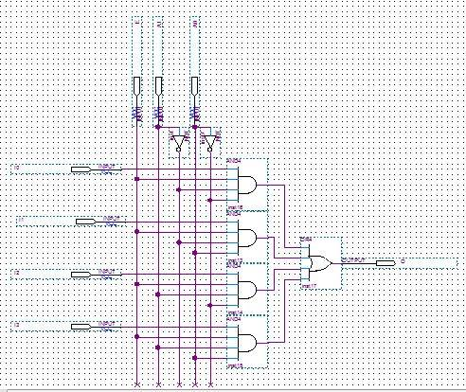

3.

I0 I1  I2 I3 I4 I5  I6 I7

|  |
| --- |
| 0 1 2 3 4 5 6 7  8 9 10 11 12 13 14 15 |

A’

A

1 0 0 1 A’ A A’ A

4. 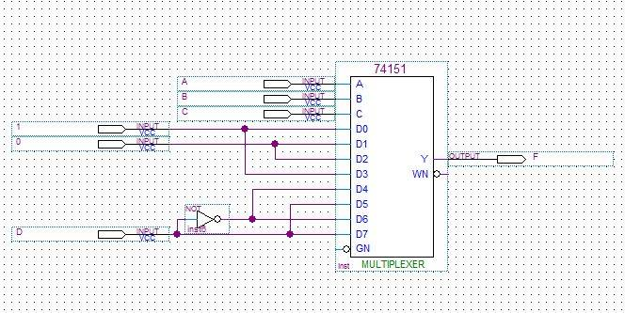

**Summary:**

Here we write the truth table of a multiplexer using 4-to-1-line with active LOW enable input and draw this with random gates. Also implemented the 8-to-1-line multiplexer .

**EAST WEST UNIVERSITY**

**Semester:** Fall 2016

**Course Number:** CSE 345

**Course Title:** Digital Logic Design

**Experiment No:** 06

**Experiment Title:**

**Name:** Md. Sakibur Rahman

**ID:** 2014-1-60-032

**Group Number:** 02

**Group IDs:**

2014-1-60-032

2014-1-60-024

2014-1-60-030

2014-1-60-055

**Date of Performance:** November 30, 2016